**Ragnarok Coding Exercise Instructions**

As we mentioned, this is more intended for us to grasp an understanding of your style and skill.

Shortly, you'll be receiving an invite to join our Sandbox environment inside the Iterable platform. Your access will be limited, but will suffice in you being able to develop a coded template.

After you receive your invite and login, click this link to access your template list and then click into your template:

[https://app.iterable.com/templates](https://app.iterable.com/templates/edit?templateId=1017569)

Iterable is a fairly simple interface. You'll want to make sure you save your work using the Green Button before closing the tab or previewing and updates when using the Preview with data (explained below).

Please see the attached design for what you should build.

For the first section, you can upload images directly on the Iterable platform using the WSYWIG option, as indicated in the screenshot below. This will paste the image directly into the code, where you can retrieve the URL.

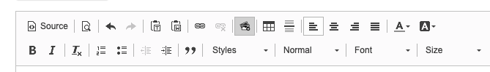

The products that are shown in the middle section should be dynamic based on the JSON payload attached; you will not need to directly slice nor type any of those fields. **Note, these images have changed from the design file you are referencing and this is absolutely okay!** For coding that section, please refer to Iterable's Handlebars documentation to get a sense of their operators and statements you can use:

<https://support.iterable.com/hc/en-us/articles/205480365-Using-Contact-Properties-Event-Properties-and-Handlebars-Logic#working-with-lists-arrays>

Because this section is dynamic, in order to test it, you'll need to click "Preview with data"

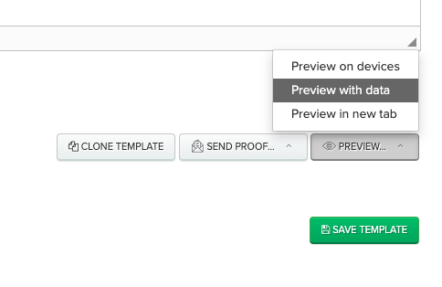

Then, directly paste in the JSON payload into the right hand box and click the green "Refresh Preview" button to load the template with the live data.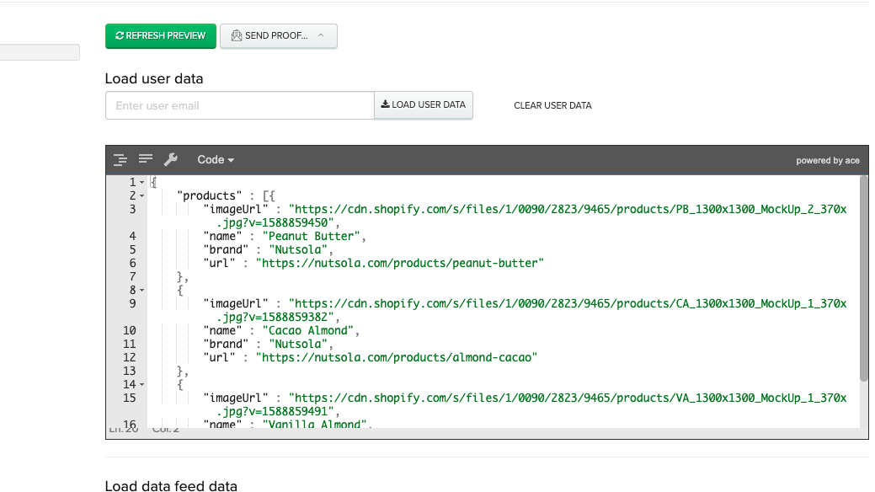

For any URLs, you can just use a # symbol.

After you've built your template, please send a test to [nicol@ragnaroknyc.com](mailto:nicol@ragnaroknyc.com), jamescecire@ragnaroknyc.com, and spencer@ragnaroknyc.com

If you have any questions, please respond here.